**MUSIC STORE ANALYSIS**

**Q1) Which countries have the most invoices?**

Select count (*) as c, billing country from invoice

group by billing country

order by c desc

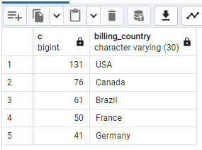

**Q2) Who is the best customer? Write a query that returns the person who has spent most money.**

select customer.customer_id, customer.first_name, customer.last_name, SUM(invoice.total) as total from customer

JOIN invoice ON customer.Customer_id = Invoice.customer_id

GROUP BY customer.customer_id

ORDER BY total DESC

limit 1

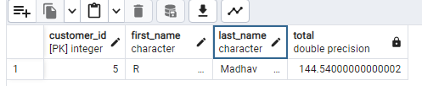

**Q3) Which city has the best customers? Write a query which returns top cities that has the highest sum of invoice total. Return both the city name & sum of all invoice total.**

Select sum(total) as invoice_total, billing_city from invoice

group by billing_city

order by invoice_total desc

limit 5

**Q4) Write query to return email, first name, last name, & genre of all rock music listeners. Return your list ordered alphabetically by email starting with A.**

select c.first_name, c.last_name, c.email from customer as c

join invoice on c.customer_id = invoice.invoice_id

join invoice_line on invoice.invoice_id = invoice_line.invoice_id

where track_id in

(select track_id from track join genre on genre.genre_id = track.genre_id

where genre.name like 'Rock')

order by c.email

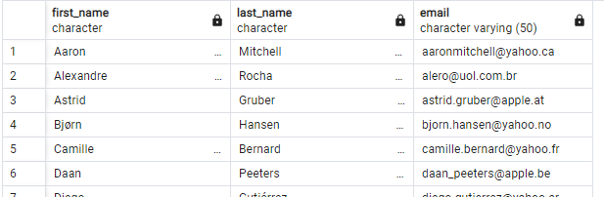

**Q5) Lets invite the artists who have written the most rock music in our dataset. Write query that returns the artists’ name and total track count of the top 10 rock bands.**

select artist.name, count(artist.artist_id) c from artist

join album on album.artist_id = artist.artist_id

join track on track.album_id = album.album_id

join genre on genre.genre_id = track.genre_id

where genre.name = 'Rock'

group by artist.artist_id

order by c desc

limit 10

**Q6) Return all the track names that have a song length longer than the average song length. Return the names and milliseconds for each track, order by song length with the longest song listed first.**

select name, milliseconds from track

where milliseconds > (select avg(milliseconds) from track)

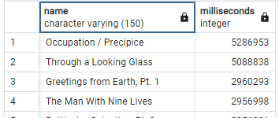order by milliseconds desc

**Q7) We want to find out the most popular music genre for each country. We determine the most popular genre by highest amount of purchase.**

with popular_genre as

(select count(invoice_line.quantity) as purchase, customer.country,

genre.name, genre.genre_id,

row_number() over (partition by customer.country order by

count(invoice_line.quantity) desc) AS row_no

from invoice_line

join invoice on invoice.invoice_id = invoice_line.invoice_id

join customer on customer.customer_id = invoice.customer_id

join track on track.track_id = invoice_line.track_id

join genre on genre.genre_id = track.genre_id

group by 2,3,4

order by 2 asc, 1 desc)

select * from popular_genre where row_no <=1

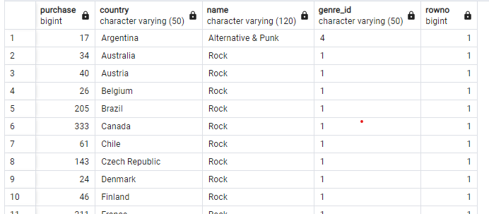

**Q8) Find how much amount spent by each customer on artists? Write a query to return customer name, artists name and total spent.**

with best_selling_artist as (

select artist.artist_id, artist.name artist_name,

sum(invoice_line.unit_price*invoice_line.quantity) as total

from invoice_line

join track on track.track_id = invoice_line.track_id

join album on album.album_id = track.album_id

join artist on artist.artist_id = album.artist_id

group by 1

order by 3 desc

limit 1)

select customer.customer_id, customer.first_name||' '||customer.last_name Customer_name,

bsa.artist_name, sum(invoice_line.unit_price*invoice_line.quantity)

as total_spent from invoice

join customer on customer.customer_id = invoice.customer_id

join invoice_line on invoice_line.invoice_id = invoice.invoice_id

join track on track.track_id = invoice_line.track_id

join album on album .album_id = track.album_id

join best_selling_artist bsa on bsa.artist_id = album.artist_id

group by 1,3

order by 4 desc

limit 10